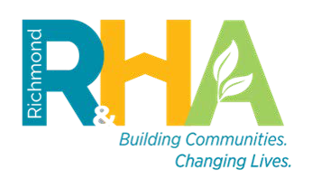
Richmond Redevelopment and Housing Authority
901 Chamberlayne Parkway
Richmond, Virginia 23220
TTD/TTY Virginia Relay Service

HCVP Customer Service: 804-780-4200

HCVP HOME Interest Form
The family named below has advised Richmond Redevelopment and Housing Authority of their interest in the HCV Homeownership Option. RRHA requires this Homeownership Request Form to be completed by the family to verify the family’s intent to become homeowners. Families not in compliance with the HCV program and lease obligations may not be eligible for homeownership. The family will also be reviewed for additional homeownership eligibility requirements. Please note, additional documentation may be required in order to determine qualification for the Homeownership Program.
TO BE COMPLETED BY THE HEAD OF HOUSEHOLD
Only adult family members participating in the HCV Program will be considered for homeownership

Tenant ID: Email:

Name of Head of Household

Name of additional family member to pursue financing
(leave blank if same as above)

I, , am a current participant of the RRHA Housing Choice Voucher Program and I am interested in participating in the Homeownership Program.

I certify under penalty of perjury the following to be true and correct (Please INITIAL if applicable):

I am a current RRHA Section 8/ HCV participant or eligible for admission to the RRHA HCV Program  I am in good standing and have no outstanding debt to  RRHA or unpaid rent.  I or any of my household members are not in default on any mortgage  I am in compliance with my current lease.  I do not have a history of late rental payments (history of late payments is within the last 6 months). | I have been employed full-time for at least 1 year (Elderly and disabled, exempt from this criteria).  I would be considered a first-time home buyer ( no homeownership within the last 3 years).  No interest in any real property  I am Income eligible (I earn at least $14,500 annually, Elderly and Disabled, exempt from this criteria).  Estimate of credit score for adult family member to pursue financing:

I/We certify that the information given to the RRHA Housing Choice Voucher Program is accurate and complete to the best of my/our knowledge and belief. I/We understand that false statements or information are punishable under Federal law. I/We also understand that false statements or information are grounds for termination or participation in the Housing Choice Voucher Program. I also understand that this request will be used to determine my eligibility for using my voucher as payment towards mortgage if approved by a Lender.

Signature of Head of Household Phone number Date

*Please note that completing this request for homeownership does not guarantee your acceptance into the HCV Homeownership Program

RRHA Housing Choice Voucher Homeownership Program - Interest Request Form

