R I C H M O N D R E D E V E L O P M E N T A N D H O U S I N G A U T H O R I T Y
PUBLIC NOTICE

Administration & Finance Committee Meeting

***MEETING CANCELLATION***

TODAY’S DATE: August 2, 2023

WHO: The Richmond Redevelopment and Housing Authority’s (RRHA) Administration & Finance Committee In-Person Meeting

WHEN: (scheduled for) Tuesday, August 15, 2023 at 6:00 p.m.

WHAT: The Administration & Finance Committee Meeting originally scheduled for Tuesday, August 15, 2023 at 6:00 p.m. is CANCELLED.

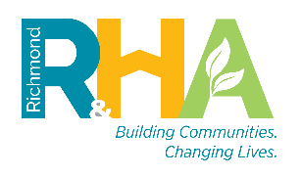
600 East Broad Street, 5th Floor, Richmond, VA 23219 | 804.780.4200 | Fax: 804 780-0009
Website: www.RRHA.com |Twitter https://twitter.com/VibrantRRHA | Facebook https://www.facebook.com/pg/VibrantRRHA
Instagram: https://www.instagram.com/vibrantrrha/ | Linkedin: https://www.linkedin.com/company/rrha/

