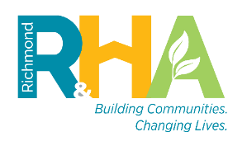



**NOTICE OF AUXILIARY AIDS AND SERVICES**

Richmond Redevelopment and Housing Authority (RRHA) is obligated to make available, at no charge, auxiliary aids and services where necessary to ensure effective communication with Individuals

with Disabilities.

**What is an auxiliary aid and service?**

An auxiliary aid and service is a device or service that enables individuals with impaired sensory, manual, or speaking skills to have an equal opportunity to participate in and enjoy the benefits of programs or activities conducted by RRHA.

An auxiliary aid and services is provided at no cost to an RRHA applicant and/or program participant.

Examples of auxiliary aids and services include sign language interpreting services, Brailed materials, screen reader software, and large print materials.

**When can I ask for auxiliary aid and service?**

You can ask at **any** time.

**How do I ask for an auxiliary aid and service?**

A request for an auxiliary aid and service can be requested online, in-person at RRHA’s Property Management Offices or RRHA’s Main Office, or by calling (804) 780-4200 (Telecommunication Relay Service by Calling 7-1-1). A request can be made ***verbally or in writing*** to an RRHA employee.

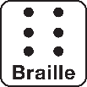

***



**What kind of information do I need to give to RRHA?**

You will need to tell us what you need and how it relates to your disability. All information we receive from you will be kept confidential.

**What happens after I ask for an auxiliary aid and service?**

We will respond to you as quickly as possible. We may ask you for more information that will be limited to us understanding the disability-related need for your accommodation or auxiliary aid and service.

**For questions or help with your request, please contact**

*Calandra Trotter*

Assistant Vice President for Housing Compliance

& Section 504 Coordinator

600 East Broad Street, 4th Floor

Richmond, VA 23219

Phone: (804) 780-4200 (TTY 711) or Email: compliance@rrha.com